Constable a well know English landscape painter from the early eighteenth century produced many drawings and watercolour studies of skies. He was known principally for his landscape paintings of Dedham Vale, the area surrounding his home and was fascinated by the English countryside with its typical fast moving clouds and changing weather patterns. Below is an example of a study in his sketchbook with accompanying notes from a poem.

See also the link to the V & A site; an article on ‘Constable Watercolour Sketches’:

<https://www.vam.ac.uk/articles/constables-watercolour-sketches>

**[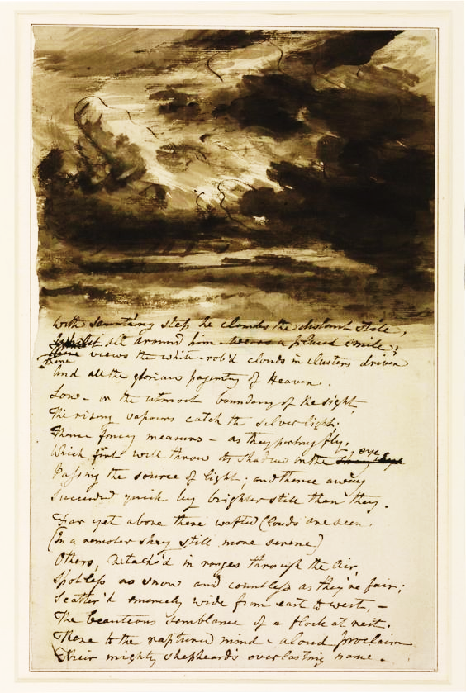](http://www.tate.org.uk/art/artworks/constable-cloud-study-with-verses-from-bloomfield-t01940)**

The popular theme of Landscapes is used by many contemporary artists where the sky invariably plays an important role.

Very often, painting a plain blue sky, lightened off towards the horizon using a graduated wash works well for many compositions; the simplicity of the sky does not detract from the rest of the landscape.

However, sometimes the Artist yearns for a little more interest, with clouds and cloud shadow. Indeed at times, a flat very simple landscape takes backstage to a dramatic sky which becomes the focus of the painting.

**Brief:** Background:

This week we are focusing on building dramatic skies to evoke mood and atmosphere using strong washes and chiaroscuro in our work. We are going to try and use our own photos but found photos will be fine as long as we keep the composition simple with a predominant sky in the frame.

Watch the video clips and my practical examples on painting a simple landscape with skies. There are two main techniques here; one where you ‘lift’ the paint with a tissue and dry brush and another technique working on separate sections of the page to build the sky and clouds. The video clips also show the palette of colours used in each of the paintings and how these are mixed and applied to different areas of the composition to give the work ‘unity’.

Look at the links to the Gallery websites where they take a closer look at Constable’s work and also his watercolour sketches of the English Countryside. One site compares Constable with Turner, both Romantic painters of the time but very much rivalries. Turner enjoyed much success in his time; Constable struggled to get his work recognised and his paintings and drawings only gained real value after his death. Turner was all about ‘Drama’ whereas Constable enjoyed portraying atmosphere and moods.

**Brief:** Your Task:

**Using your photograph compile a suitable composition which makes the sky the focus of the work. Produce a painting which evokes mood for the viewer. This could be from a stormy sky to a very tranquil summer sky with fluffy white clouds.**

**What to Do:**

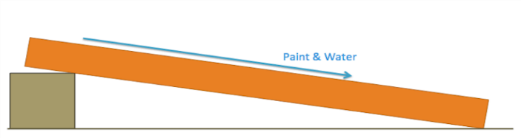

1. Set up your board with some watercolour paper as above. Have a go at following the YouTube clips on painting sky and clouds using the two techniques of ‘lifting’ out the clouds and painting around the clouds. These two techniques were also demonstrated during our live session. This is important to gain understanding and practice before you embark on your own work.
2. Set up a sheet of at least A4 watercolour paper preferably taped to a board. On one side make a few small pencil thumbnail sketches using your photograph to sort out composition and light and shade. Make sure the sky takes up at least 2/3 of the composition.
3. Choose your palette and make swatches of the colour mixes on the side of the paper. Below is an illustration of a common palette used for summer landscapes since they are ‘warm colours’. Plan the washes you will need to do your sky and make up enough for the area you are to work in. Plan your technique; will you lift out the clouds or build around them? How will you paint the stretch of simple landscape?

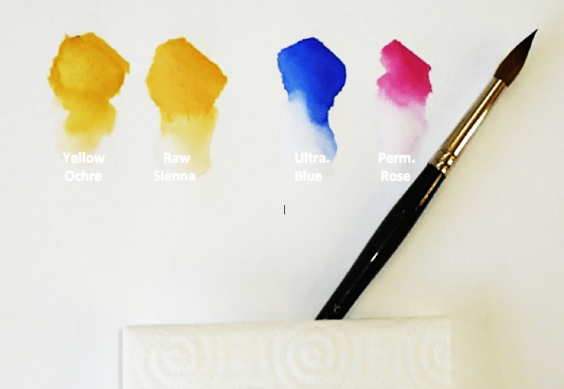

1. With your biggest brush, quickly wet the whole of the paper.  It needs to be fairly damp, but not flooded. Leave it for another 60-90 seconds, depending on how warm or cool your working area may be. The paper needs to be ‘barley damp’ to allow the paint to work wet on wet and create even washes but not too wet where the paint just thins and spreads too much.
2. You will need to work quickly before your paper does dry out. If you have spent time planning you will save yourself time and having to redo your piece. Below is an example of a graduated wash fading into a subtle warm yellow ochre tint at the bottom to blend and link with the landscape. The warm ultramarine blue and warm yellow tones suggest summer. You can just see the wash is still damp from the cockling of the paper and ready for the clouds to be ‘lifted out’.





