COLOUR: Colour Groups and Colour Schemes

Before I list suggested groups of colours for different themes and seasons it is important to have a basic understanding of certain groups of colours in the colour wheel.

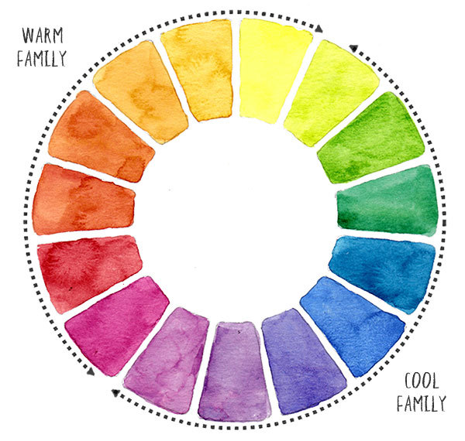

**Analogous:** Harmonious Colours

When you choose three or four neighbouring colours on the colour wheel, you get analogous colours. Associating colours like this tends to produce calming, harmonious results. You will also get bright vivid colours because of the close relationship between your paint hues. It’s only when you start mixing a complementary colour (colours on the opposite side of the colour wheel) that colour mixes become muted and de-saturated. Analogous colour schemes are one of the simplest ways to achieve pleasing colour effects.

**Split Complementary**

A split complementary colour scheme is a bit of a variation on the complementary. It makes use of the same visually contrasting hues, but softens the result slightly by using colours adjacent to the opposite complement. It adds more variation. When the colours are mixed together you get some good harmonies because each of the new colours contain some of the parent colours.

**Complementary Analogous**

A variation on the analogous colour relationship. As the name suggests, you take an analogous group of colours and then you add a complementary colour. This will give you smooth harmonious analogous colours and a vivid contrasting

COLOUR: Colours for Themes and Seasons

**Spring**

* Naples Yellow
* Lemon Yellow
* Hookers Green
* Cobalt Blue
* Alizarin Crimson
* Raw Umber

**Summer**

* Yellow Ochre
* French Vermillion (A Warmer red)
* Cadmium Yellow/ Cadmium Red
* French Ultramarine
* Cobalt Blue
* Raw Umber
* Sap Green

**A Note on Warm Blues**: Warm blues are those with a purple bias rather than a green bias. They will appear to come forward in a painting, whereas cool blues will recede. It is useful to have a warm and a cool blue in a split primary palette - when mixed together they will create a mid-blue. Examples of warm blues are **Ultramarine**, **Indanthrone Blue** and **Cobalt Blue**

**Autumn**

* French Ultramarine mixed with Cobalt Blue
* Raw Umber
* Yellow Ochre
* Alizarin Crimson
* Cadmium Yellow
* Cadmium Red
* Burnt Sienna

**Winter**

* Cobalt Blue mixed with a little French Ultramarine
* Lemon Yellow
* Phthalo Blue
* Indigo Blue
* Raw Umber
* Cerulean Blue
* Crimson (A cooler red)

**Added Note on Cool Blues** **for Winter**: **Cool blues** are those with a green bias. There are many of them - Phthalo Blue, Prussian Blue, Cerulean blue, Manganese Blue, Winsor Blue

Colours for Themes and Seasons (cont.)

**Architecture &Urban Landscape** (This does depend on the brick and age of the buildings)

* Raw Umber
* Yellow Ochre mixed with French Ultramarine
* Burnt Sienna
* Older buildings tend to warrant warmer colours such as cadmium red mixed with yellow ochre and burnt sienna
* Modern, newer buildings tend to warrant cooler colours such as cool blues like Cerulean Blue mixed with Cool reds such as Crimson Red

**Rural Landscape** (This also depends on the seasons)

* Alizarin Crimson
* Greens such as Sap Green mixed with Yellows and Blues
* Burnt Umber
* Raw Sienna
* Yellow Ochre

WARM V COOL

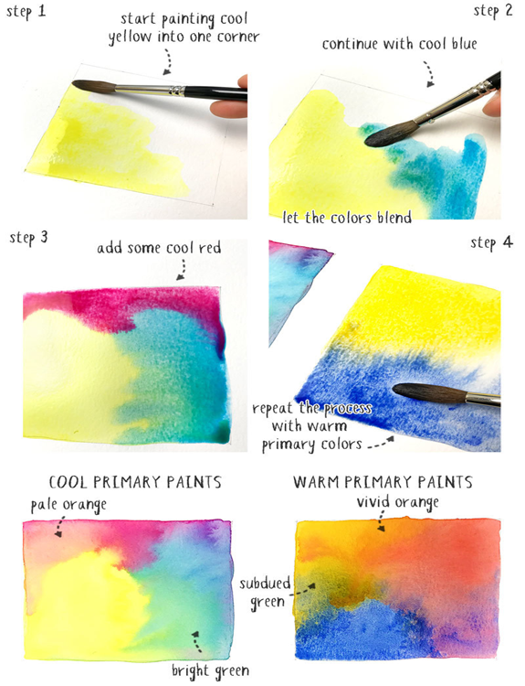Notice the difference between the two squares. Even though primary colours are used for each, the colour appearance is completely different. For example, cool yellow and cool blue blend to make a nice bright green, perfect for spring. On the other hand, warm yellow and warm blue produce a more subdued olive green mixture, good for summer. The resulting purples and oranges are also very different.