An Introduction to Colour:

A small minority of us have a natural colour sense and can mix a colour accurately. However, the majority of us have varying degrees of difficulty mixing the correct colour.

**Colour Theory of Johannes Itten**

At the Bauhaus, the important introductory course in colour was taught by Johannes Itten (1888 - 1967), a Swiss-born abstract painter whose own works were filled with swirling, vibrating coloured shapes. Itten taught using a colour sphere of the 12 hues, evenly spaced with complementary colours diagrammatically opposite each other; for example, purple is opposite yellow; blue to orange and red to green. If you think this was complicated, the artist Delacroix kept a 72-hue colour circle mounted on a wall in his studio, each colour labelled with possible combinations!

The primary colours, yellow, blue and red are shown in the triangle in the centre. Interestingly there are a variety of paint manufacturers who produce a variety of these primary colours but few of them make pure primaries. A true primary is neither warm nor cool.

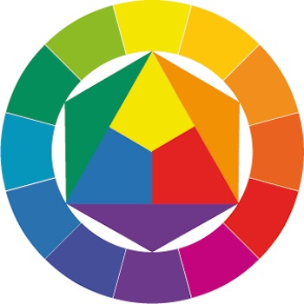**Johannes Itten colour sphere**

Contrast

First was contrast of hue, the mixing of different hues from the colour wheel. The farther apart the hues, the greater the contrast. For example, bright yellow and purple contrast more than yellow and green or yellow and orange. Second was light and dark contrast, when tints or shades are placed next to an extreme opposite. In the most basic sense, think of white as opposed to black. Light and dark contrast could be used in monochromatic compositions (images done with tints and shades within one hue).

Warm & Cold

Itten also taught of colour as a cold - warm contrast, relating colours to different temperatures. This is probably one of his most lasting contributions to colour theory. Cool colours include blues and greens, while warm colours include red, orange and yellow. The idea stuck, and you will still hear this terminology used today -- even with clothing designersand makeup artists.

**The Difference between Warm and Cool Colours**

It is important for you to be able to differentiate between warm and cool colours, otherwise your mixing abilities could be compromised. For example, the wrong blue and red will not make purple; they will make brown. To help you differentiate between warm and cool colours, two colour circles are shown below, giving 12 warm hues and 12 cool hues. Note how the warm yellow and warm blue make a dull green whereas the cool yellow and cool blue makes a vivid green

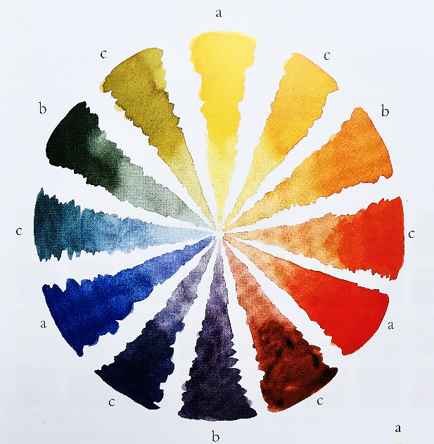

**The Warm Colour Circle**

a= Primary; b= Secondary; c= Tertiary

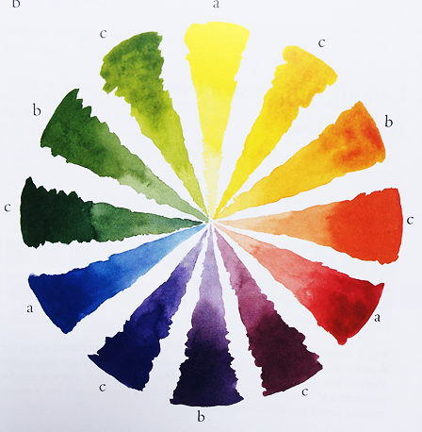

**The Cool Colour Circle**

A= Primary; b= Secondary; c= Tertiary

**EXAMPLES OF PAINTED STILL LIFE WITH DOMINANT COLOUR THEMES:**

Can you work out what the colour theme is and where they are on the colour wheel?

Are they analogous? Complementary? Warm or Cool? How does this effect the overall mood of the painting?

**[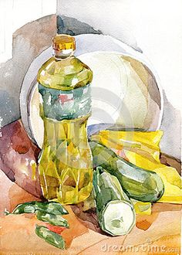](https://www.pinterest.co.uk/pin/557179785148365253/)[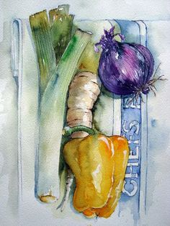](https://www.pinterest.co.uk/pin/501377371006818464/)[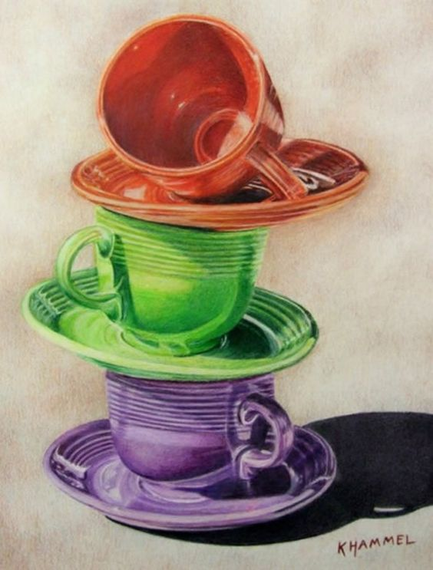](http://www.annkullberg.com/images/shows/Theme13/Ver/Khammel.jpg) [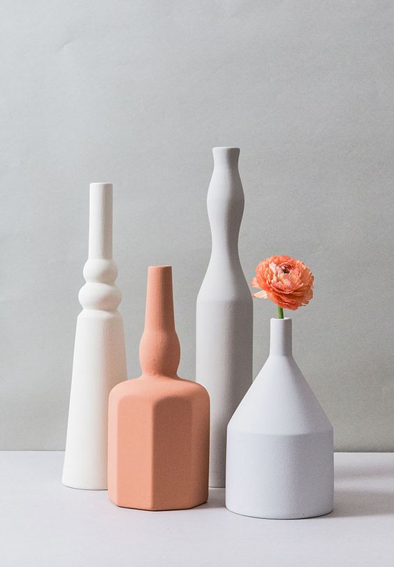](http://designgallerist.com/blog/morandine-objects-brought-life-sonia-pedrazzini/) [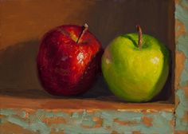](https://www.pinterest.co.uk/pin/237494580324678906/) [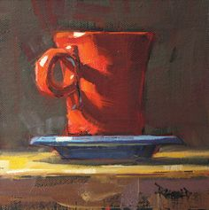](https://www.pinterest.co.uk/pin/461970874275736467/)** 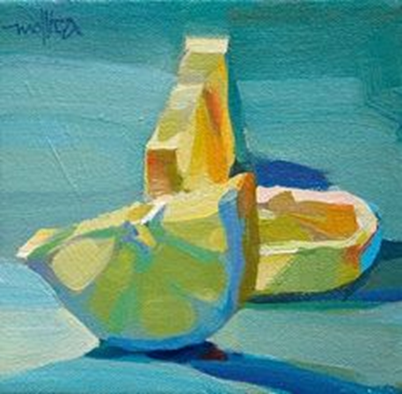

**[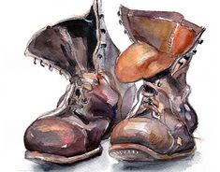](https://www.pinterest.co.uk/pin/416371928043744613/)[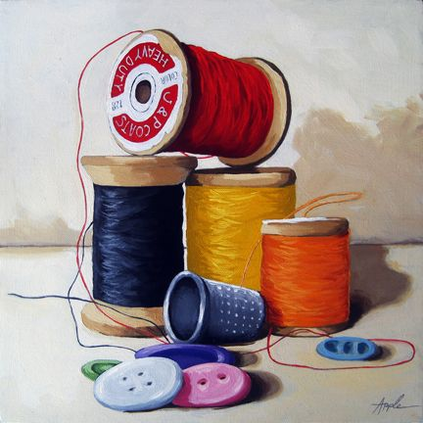](http://www.applearts.com/content/sewing-time-realistic-still-life-oil-painting)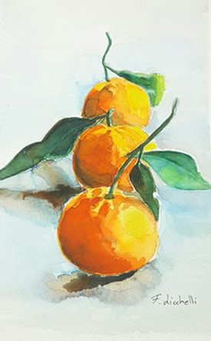[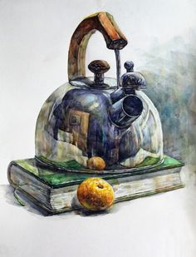](https://www.pinterest.co.uk/pin/859906122591775023/)[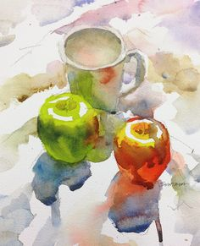](https://www.pinterest.co.uk/pin/775815473297819372/)**

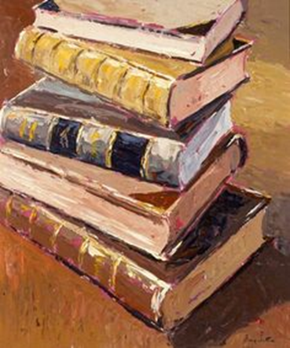

**[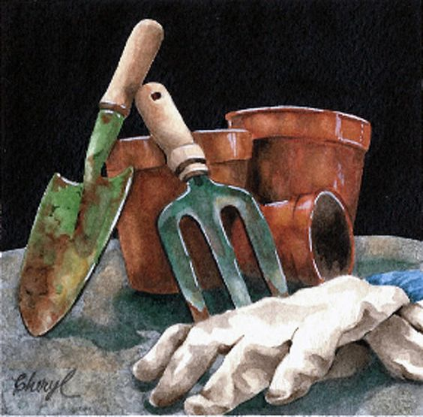](http://fineartamerica.com/featured/pot-party-cheryl-bannister.html)**

**Brief:**

Watch the video clip and have a look at the website link on setting up a still life using specific colour themes, setting up a light source and arranging the composition of your chosen objects.

Last week we concentrated on simple themes which reflected on personal interests or hobbies. We focused on pattern, shapes and chiaroscuro and considered composition and positioning elements within the frame.

**The Rules:**

This week I want to pay more attention to the negative and positive space within the frame and colour. The three rules are:

1. You are only allowed up to three objects.
2. You must select a colour theme from the following: Analogous; Complementary or Primary. Select your objects accordingly. For example, for a complementary theme a purple bowl with a yellow tablecloth. Or for an analogous theme, a blue vase with blue/purple flowers against a dark mauve cloth.
3. You must have a one directional light source

Consider the following questions:

* Will you zoom in for a close up of part of your still life or will you incorporate all of the still life?
* Which element does your painting focus on?
* Will you consider using a warm palette or cool palette? (See the colour wheel charts above).
* Which colours will you choose and stick with?

**What to Do:**

1. Set up a small still life with your chosen theme. Please have a look at the YouTube link and website link in this Topic section for ideas. Use a cardboard box as in the YouTube link.
2. Use the viewfinder to establish a suitable focused composition. You may like to encompass all the still life if it is small, or you may want to focus on just a section.
3. Make a drawing of your selected composition from still life. This helps to establish shapes, tonal values and the overall composition. Use light and dark tones to establish light source.
4. Make notes on a suitable colour palette. A suggestion would be to use either ‘Warm’ or ‘Cool’ primary colours with a darker colour for mixing contrast and shading. Use the Colour Wheel to mix your ‘group’ of colours.
5. Use your drawing to transfer into a watercolour painting.
6. Use techniques of wet on wet, wet on dry. Mix shadow colour to add shade in painting.
7. Try to paint in the whole of the composition with you first layer of colour washes. Some colours may ‘bleed’ into one another and some may be separated by a paper dam or edge. Allow to dry then add a second layer. Try to apply smooth larger areas with at least a size 8 brush rather than fiddling with a small brush; this will make the paint ‘muddy’ and show watermarks.